**Online Art Gallery**

# A Project Report

# Submitted in partial fulfillment of the

# Requirements for the award of the Degree of

**BACHELOR OF SCIENCE (INFORMATON TECHNOLOGY)**

**By**

# SIDDIQUI FARHAN DILSHAD

**Seat Number:558**

**Under the esteemed guidance of**

**Ms. Vishakha Bagwe**

# Assistant Professor



**NAGINDAS KHANDWALA COLLEGE(Autonomous)**

***(Affiliated to University of Mumbai)***

# MUMBAI, 400 064

# MAHARASHTRA

# 2022-23

**Proforma of the Project Proposal**

## PNR No.: …………………… Roll no: 558

1. Name of the Student: Siddiqui Farhan Dilshad

1. Title of the Project: Online Art Gallery

1. Name of the Guide: Ms. Vishakha Bagwe

1. Teaching/Industry experience of the Guide: 6years

1. Is this your first submission?

Signature of the Student: Signature of the Guide:

Date: ………………… Date: …………………….

Signature of the Coordinator:

Date: …………………

**NAGINDAS KHANDWALA COLLEGE(Autonomous)**

***(Affiliated to University of Mumbai)***

**MUMBAI, 400 064**

**MAHARASHTRA**

# DEPARTMENT OF INFORMATION TECHNOLOGY



**CERTIFICATE**

This is to certify that the project titled, **"** **Online Art Gallery"**, is bonafied work of **Siddiqui Farhan Dilshad** bearing Seat. No: (**558**) submitted in partial fulfilment of the requirements for the award of degree of BACHELOR OF SCIENCE in INFORMATION TECHNOLOGY from University of Mumbai.

|  |  |  |
| --- | --- | --- |
| **Internal Guide** | **External Examiner** | **Coordinator** |
| **Date:** |  | **College Seal** |

# Abstract

Reason for choosing this topic is that it majorly deals with the management of databases and functions dynamically. It is a concept which deals with artists, artworks and customers. It is a platform which updates the information about the galleries and artworks that are being exhibited. Hence, we have decided to work on the development of the web. Our main goal is to provide an easy and comfortable platform for the artists as well as customers and all the info regarding the galleries and artworks at the current situation of the exhibition of galleries. It brings all the people related to the Gallery exhibition and clearly displays the Artworks and Artist related to it and the Venues that are being held at current position. “ONLINE ART GALLERY” is a website and it is very helpful for the art lovers and others who wants to know about the artworks.

This website helps the end-users to search their arts and paintings and they can place order for the selected pieces. The end-user can also get the information about the art exhibition by contacting respective artist, so, that they can visit to those exhibitions. Art Gallery brings you an opportunity to view online artworks at our Online Art Gallery webring you details of all artworks and artists across the world. The Online Art Gallery is updated daily, so the user can view and buy the latest collection of contemporary art online from anywhere in the world. You can view and buy the latest Indian contemporary art collection available at their exhibitions and also at their online gallery.

# ACKNOWLEDGEMENT

It is with my immense gratitude that I acknowledge the support and help of my professor, **Ms. Vishakha Bagwe,** who has always encouraged me into this research. Without her constant guidance and persistent help, this project would not have been completed by me. I also thank my **family and friends** for their endless love and support throughout my life.

I am very thankful to **Prof. Dr. Moushumi Datta**, the principal of **Nagindas Khandwala College** for her kind co-operation in the completion of my project. I also Thanks **Dr. Sindhu.P.M** Head of Department of our section in college for supporting me.

I am also thankful to our **other staff** of our department for facilitating me with the necessary requirements and support and co-operation. My project experience was satisfying, fulfilling acknowledge filled lastly, I would like to thank my college **Nagindas Khandwala College of commerce, arts and science (Autonomous)** for providing me with proper ambience and supplying me with the right amenities that has helped me complete this project on time and satisfyingly.

# DECLARATION

I hereby declare that the project entitled, “**Online art Gallery**” done at **Nagindas Khandwala College**, has not been in any case duplicated to submit to any other university for the award of any degree. To the best of my knowledge other than me, no one has submitted to any other university.

The project is done in partial fulfillment of the requirements for the award of degree of **BACHELOR OF SCIENCE (INFORMATION TECHNOLOGY)** to be submitted as final semester project as part of our curriculum.

**Siddiqui Farhan Dilshad**

# TABLE OF CONTENTS

CHAPTER 1 1

INTRODUCTION 1

1.1 Background 1

1.2 Objectives 1

1.3 Applicability 1

CHAPTER 2 2

GAP ANALYSIS/DRAWBACK OF EXISTNG SYSTEM 2

CHAPTER 3 3

REQUIREMENTS AND ANALYSIS 3

3.1 Problem Definition 3

3.2 Requirements Specification 3

3.3 Planning and Scheduling 3

3.4 Software and Hardware Requirements 4

Hardware Requirements 4

3.5 Preliminary Product Description 5

CHAPTER 4 6

SYSTEM DESIGN 6

4.1 Modules 6

1. ER DIAGRAM 6

Class diagram 7

Activity diagram 10

Sequence diagram 11

4.4 User Interface Design 12

4.5. Security issues 13

CHAPTER 5 14

IMPLEMENTATION AND TESTING 14

5.1 Code( place core segment) 14

5.1 Testing Approach and Test Cases 22

CHAPTER 6 24

RESULTS AND DISCUSSION 24

6.1 Test Reports 24

6.2 User Documentation 25

CHAPTER 7 26

CONCLUSIONS 26

7.1 Conclusions 26

7.1.1 Significance of the System 26

7.2.1 Limitation of the System 27

7.3 Future Scope of the Project 27

REFERENCES 28

APENDIX 29

# List of Tables

Table 1: Gantt chart 3

Table 2: Test Case: Login 22

Table 3: Test Case: Registration 23

Table 4: Test Reports: Login 24

Table 5: Test Reports: Registration 24

**List of Figures**

Figure 1.1 Gantt Chart 4

Figure 2.1 ER Diagram 6

Figure 3.1 Class Diagram 7

Figure 4.1 Use Case Admin 8

Figure 4.2 Use Case Customer 9

Figure 5.1 Login Activity 10

Figure 5.2 Registration Activity 10

Figure 5.3 order booking activity 11

Figure 6.1 (Sequence Diagram for Admin to manage order) 11

Figure 6.2 (Sequence Diagram for Customer) 12

Figure 7.1 Home page 17

Figure 7.2 Login page 17

Figure 7.3 Registration page 18

Figure 7.4 Welcome page 19

Figure 7.5 Feedback page 19

Figure 7.6 Booking page 20

Figure 7.7 Payment page 21

Figure 7.8 Admin login 22

# 

# CHAPTER 1

# INTRODUCTION

## 1.1 Background

Online Art gallery is an website that allows buyers to purchase paintings, scriptures, models online. The purchase is just a click away, you don’t have to go to some old museums and buy from selected stuff.

This website will provide you with a wide range of choices. The registration in this website is free, unlike other sites. It provides various categories too, in buyers’ accordance. It provides home delivery to buyers. It allows users to create their own portfolios. The basic need for making this website is to increase the growth of the shop and spread awareness among the people about the shop so that the owner of the shop would get more profit. Later the thing it would contain the about us page where it would give a brief description of the shop the specialty of the shop. This online rental costumes system consist of payment option where payment can be done through cash on delivery.. Where I am creating a website, which would particularly allowing the customer to buy the painting from the favorite artist This project i.e. online art gallery is very helpful for customer where customer can buy directly paintings from home through internet connection where internet connection is must. This can be done through mobile phone or system.

## 1.2 Objectives

The main objective behind this project is to promote artists working on different themes and ideas. It provides them platform to exhibit and sell their creations online in affordable rates. Moreover, online application attracts many viewers by allowing them to buy paintings from their houses, offices in just a fraction of seconds, narrowing the geographic distances.

## 1.3 Applicability

This project delivers the following benefits:

* Promote Art through media of web
* Buy & Sell art work globally.
* Any Art Work can be promoted, no restriction of Art medium.
* Latest Profitable Links in Indian Art Context Shared as resources Unlimited Artist workspace.
* Easy to use web application for Photographers, Artists.
* Show case India's rich Culture, Tradition and artwork.

Thus, this project will serve the computer world and people in the above ways by providing a virtual gallery globally

# CHAPTER 2

# GAP ANALYSIS/DRAWBACK OF EXISTNG SYSTEM

Customer can also register online and they can browse art works that are arranged in different categories scientifically. Each Customer can create their own gallery to see his favourite art works with out much difficult. And each user has the right to purchase an art work using the integrated payment gateway and participate in auction by submitting their bids. Qualified bidder should remit the amount using payment gateway and after each valid payment the art work will be shipped within some days.

**Limitation of Existing System**

* Lack of security data.
* More man power.
* Time consuming.
* Consumes large volumes of pare work.
* Needs manual calculations

# CHAPTER 3

# REQUIREMENTS AND ANALYSIS

## 3.1 Problem Definition

To provide an online platform to manage the buying, selling and storage of artistic creations provided by creators/other platforms or auctions, and to organize events to exhibit these products.

## 3.2 Requirements Specification

**Customer Registration:**

Customer register in the system.

**Customer Login:**

Customer needs to login in the system to use the facilities of the system.

**Customer Profile:**

Customer manages his/her own profile.

**Order Booking**:

Customer can order the arts from the website.

**Searching:**

Admin, customer and artist can search any Artwork and Artist.

**Contact:**

Customers can send feedback to the admin about problems related to the services.

## 3.3 Planning and Scheduling

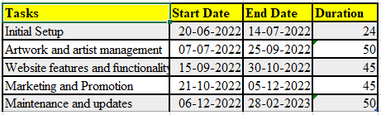

Table1: Gantt chart

Figure 1.1 Gantt Chart

## 3.4 Software and Hardware Requirements

## Hardware Requirements

* Processor used is Intel Core i3 or more.
* RAM: 4GB
* HDD: 250 GB or more

**Software Requirements:**

* **Frontend**
* Bootstrap
* Html
* CSS
* JavaScript
* **Backend**
* Php
* Apache Server
* **Database**
* MySQL

## 3.5 Preliminary Product Description

ONLINE ART GALLERY is a web application software and it is very helpful for the art lovers and others who wants to know the addresses where this kind of arts will we sold. This application helps the end-users to search their arts and paintings and they can place order for the selected pieces. The end-user can also get the information about the art exhibition and the respective address, so, that they can visit to those exhibitions. Art Gallery brings you an opportunity to view online art exhibitions at our Online Art Gallery we bring you details of all art exhibitions held in the past and the forthcoming show. The Online Art Gallery is updated daily, so the user can view and buy the latest collection of contemporary art online from any where in the world. You can view and buy the latest Indian contemporary art collection available at their exhibitions and also at their online gallery

# CHAPTER 4

# SYSTEM DESIGN

## 4.1 Modules

* Home
* User Registration
* Contact us
* Search
* Login
* Admin Login
* Buy Arts
* Cart
* View Order
* View Payment

## 1. ER DIAGRAM

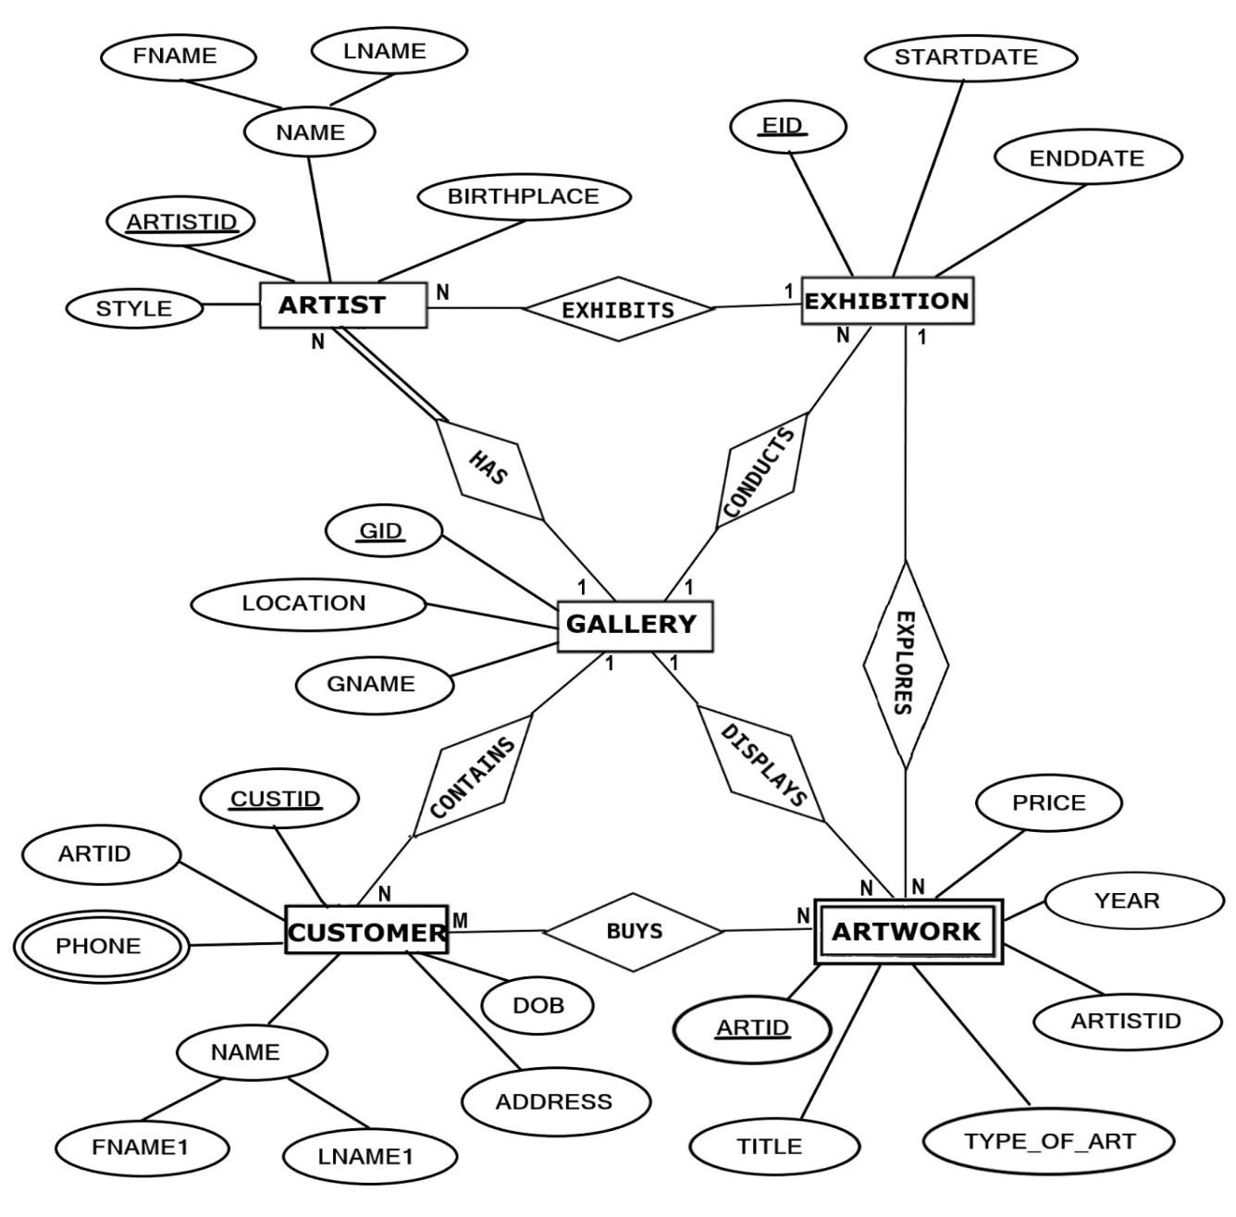

Figure 2.1 ER Diagram

## Class diagram

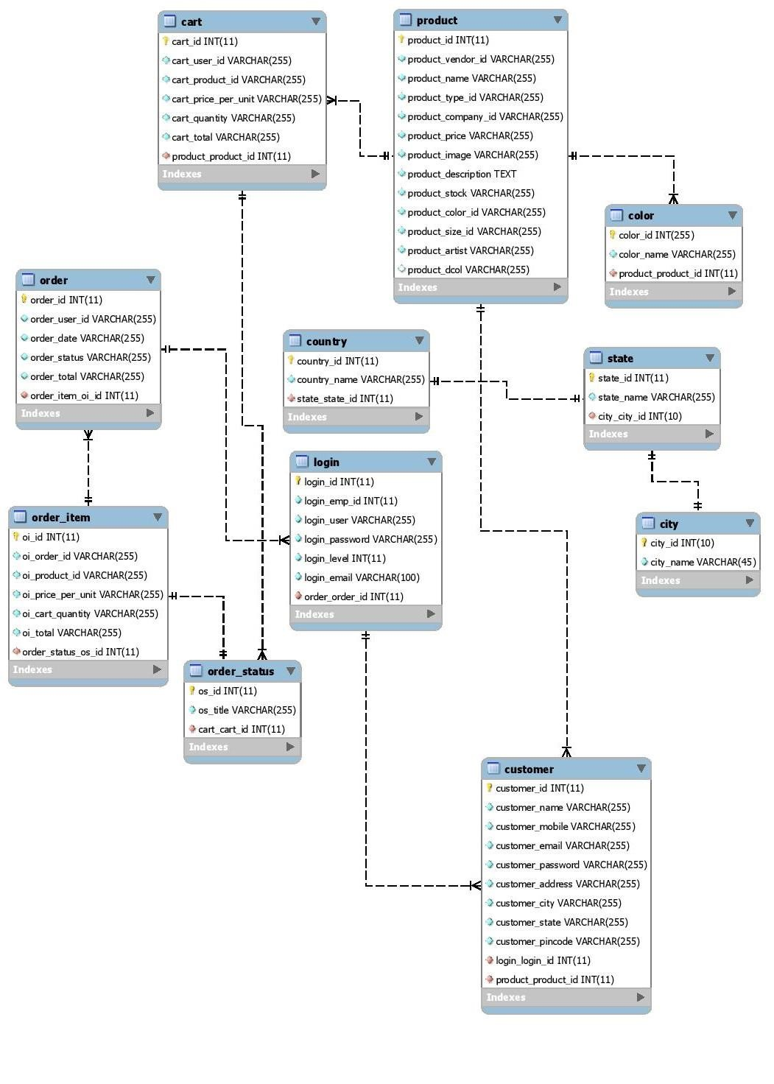

Figure 3.1 Class Diagram

**Use case diagram**

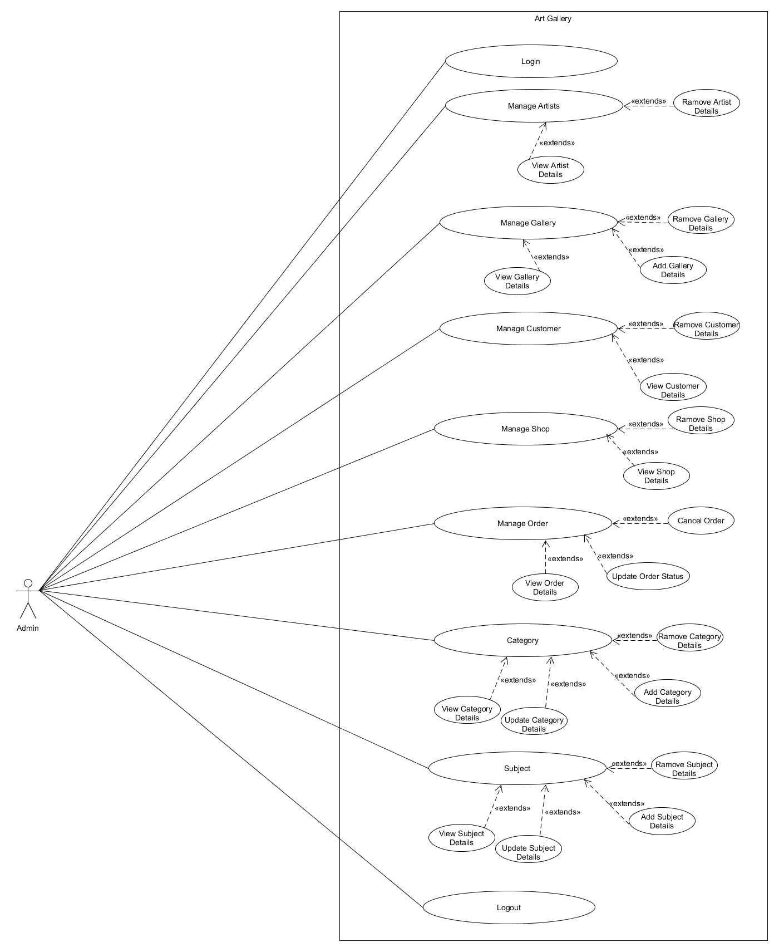

Figure 4.1 Use Case Admin

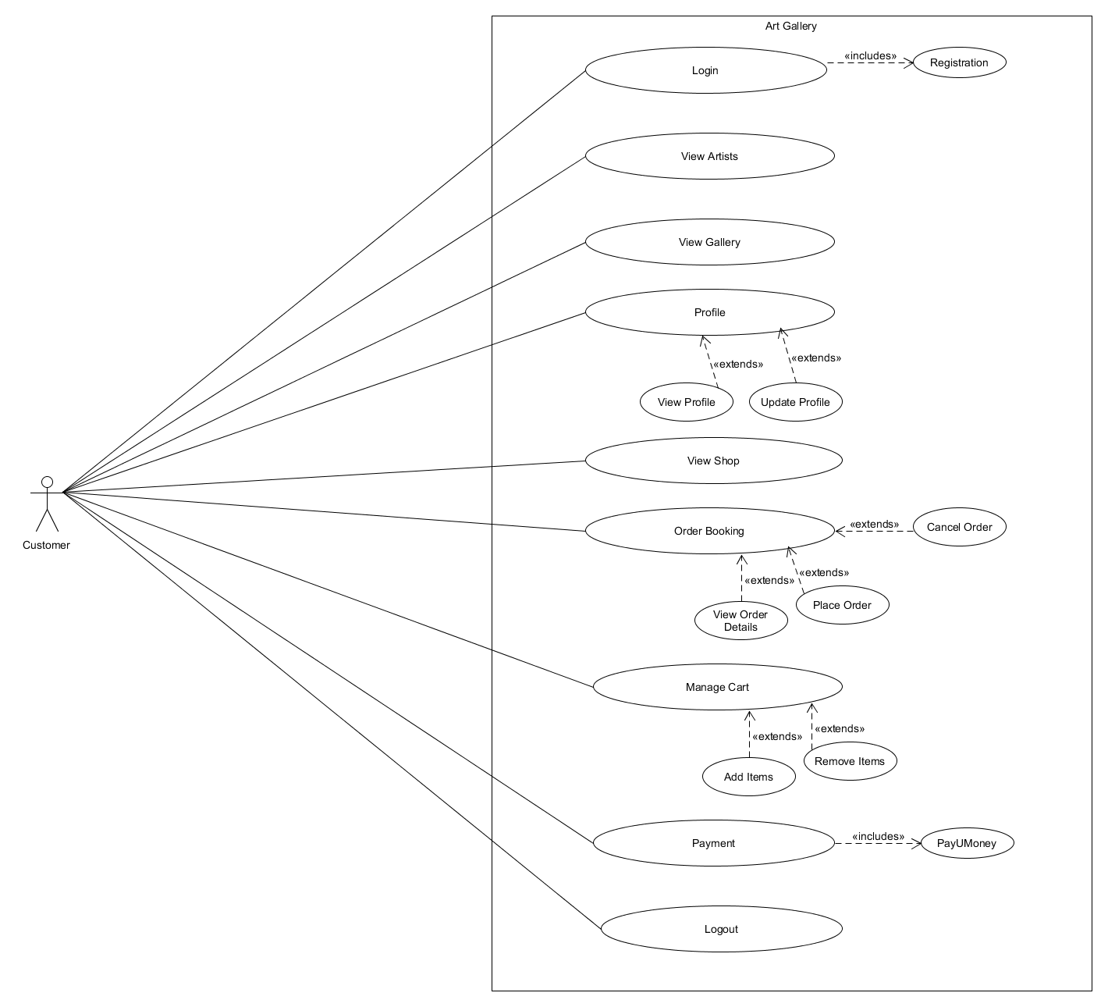

Figure 4.2 Use Case Customer

## Activity diagram

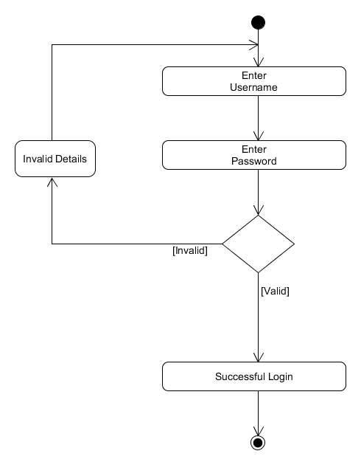

Figure 5.1 Login Activity

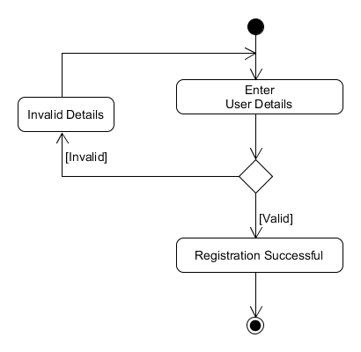

Figure 5.2 Registration Activity

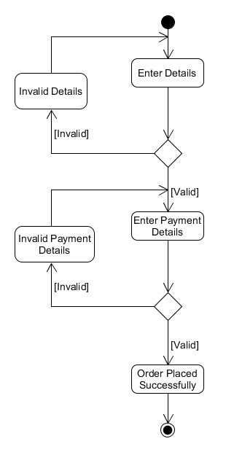

Figure 5.3 order booking activity

## Sequence diagram

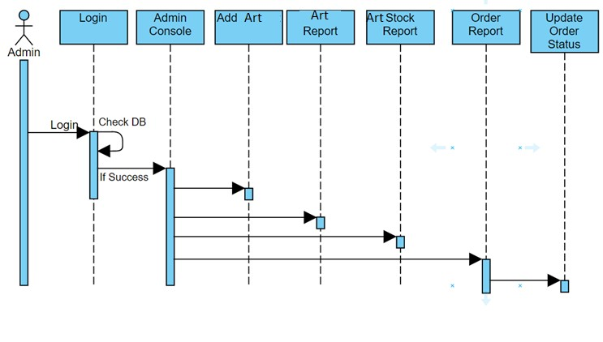

Figure 6.1 (Sequence Diagram for Admin to manage order)

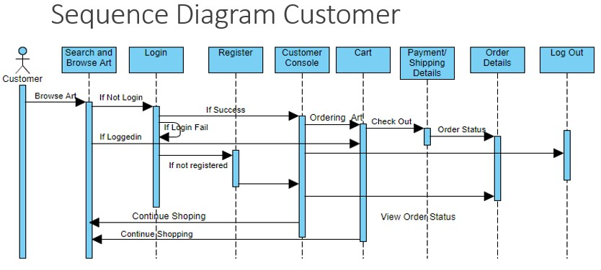

Figure 6.2 (Sequence Diagram for Customer)

## 4.4 User Interface Design

* The online art gallery website consists of three main users they are
* Admin user
* Customer user
* Admin able to login and logout.
* Customer able login and logout.
* Customers and Artist username and password and email address can only visible to administrator.
* Signup for new customer.
* Customer, Admin and Artist can change the password.
* Admin can add or remove an artist.
* Customer can search and buy an art.

## 4.5. Security issues

1. List and describe all the security issues that might be experienced while a user uses your application.

* Users can provide wrong data: Users can provide wrong data which can cause a lot of confusion and misunderstandings.
* Fake User information: Some users might make accounts which then they can use to misuse the website.
* Malicious inputs: Some people might input some subtle malicious input which might make the performance poor in future.
* Model stealing: Model stealing techniques, which are used to “steal” models.

1. Give your plan of action on how would you treat those issues.

* Perform a risk assessment
* Develop a security policy
* Develop an implementation plan
* Create a security organization
* Perform a security audit

# CHAPTER 5

# IMPLEMENTATION AND TESTING

## 5.1 Code( place core segment)

<?php

include("../connection.php");

session_start(); // Start the session

$cid = $_SESSION[ "uid" ];

?>

<!doctype html>

<html lang="en">

<head>

<title>Customer - <?php echo $_SESSION["name"]; ?> - Online Artwork & Fine Art</title>

<meta charset="utf-8">

<meta http-equiv="X-UA-Compatible" content="IE=edge">

<meta name="viewport" content="width=device-width, initial-scale=1, user-scalable=no">

<link rel="shortcut icon" href="../img/favicon.ico" type="image/x-icon">

<link rel="icon" href="../img/favicon.ico" type="image/x-icon">

<!-- Latest compiled and minified CSS -->

<link rel="stylesheet" href="../boots/css/bootstrap.css">

<!-- jQuery library -->

<!-- Latest compiled JavaScript -->

<script src="../boots/js/bootstrap.js"></script>

<link rel="stylesheet" href="../css/style.css">

<link rel="stylesheet" href="../assets/css/main.css" />

<!-- Latest compiled JavaScript -->

<script src="../boots/js/jquery.js"></script>

<!-- Scripts -->

<script src="../assets/js/jquery.min.js"></script>

<script src="../assets/js/jquery.scrollex.min.js"></script>

<script src="../assets/js/skel.min.js"></script>

<script src="../assets/js/util.js"></script>

<script src="../assets/js/main.js"></script>

</head>

<header>

<nav class="#header" >

<!-- Header -->

<header id="header" class="alt" >

<div class="logo"><a href="index.php">Online <span>Artwork & Fine Art</span></a></div>

<a href="javascript:;" style="padding: 0px 0;color:#000;margin-right: 3em;">

<form class="navbar-form navbar-left" action="welcome.php" method="post">

<div class="input-group" >

<input list="browsers" name="proname" type="text" class="form-control" style="

color: white; max-height: 35px;

" placeholder="Search Product" required>

<datalist id="browsers">

<option value="Art Deco">

<option value="Fine Art">

<option value="Folk">

<option value="Pop Art">

<option value="Street Art">

</datalist>

<div class="input-group-btn">

<button class="btn btn-default" type="submit" style="

max-height: 35px; margin-bottom: 10px;

" name="search">

<i class="glyphicon glyphicon-search"></i>

</button>

</div>

</div>

</form>

</a>

</a>

<a href="#menu"><p class="custom-para">Action</p></a>

</header>

<!-- Nav -->

<nav id="menu">

<ul class="links">

<li><a href="index.php">Home</a>

</li>

<li><a href="cancel_booking.php?id2=<?php echo $cid;?>">Cancel Booking</a>

</li>

<li><a href="add_feedback_by_cust.php?id=<?php echo $cid;?>">Feedback</a>

</li>

<li><a href="view_payment_cust.php?id=<?php echo $cid;?>">View Payment Detail</a>

</li>

<li><a href="exhibitionevents.php">View Exhibition & Events

</a>

</li>

<li><a class="a button special" href="cust_logout.php?id=<?php echo $cid;?>">Logout</a>

</li>

</nav>

</nav>

</header>

<body >

**SCREENSHOTS**

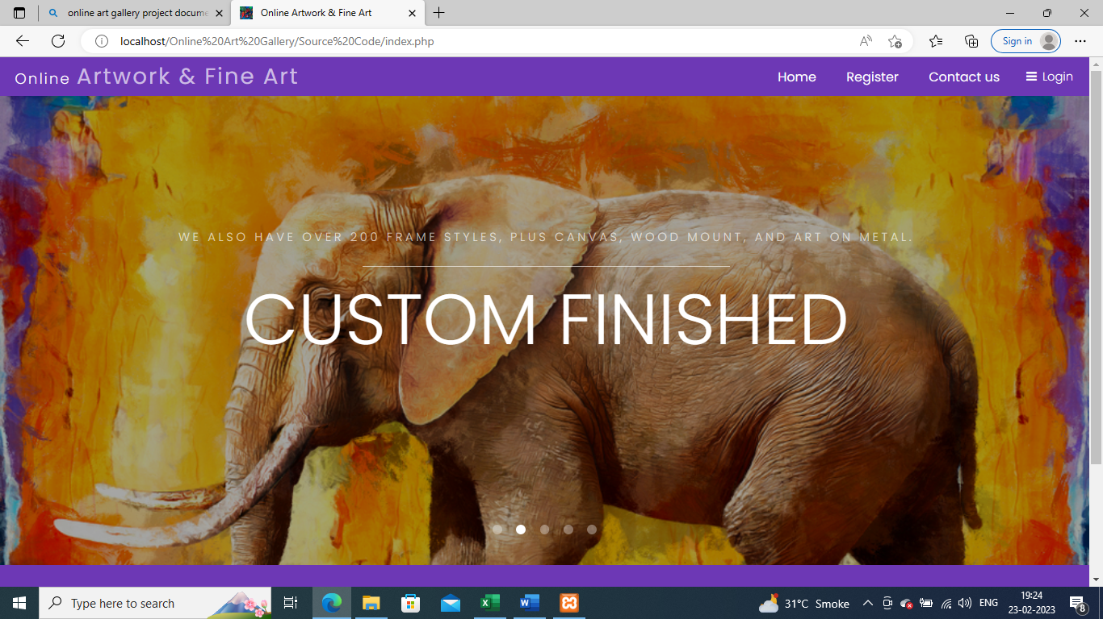

Figure 7.1 Home page

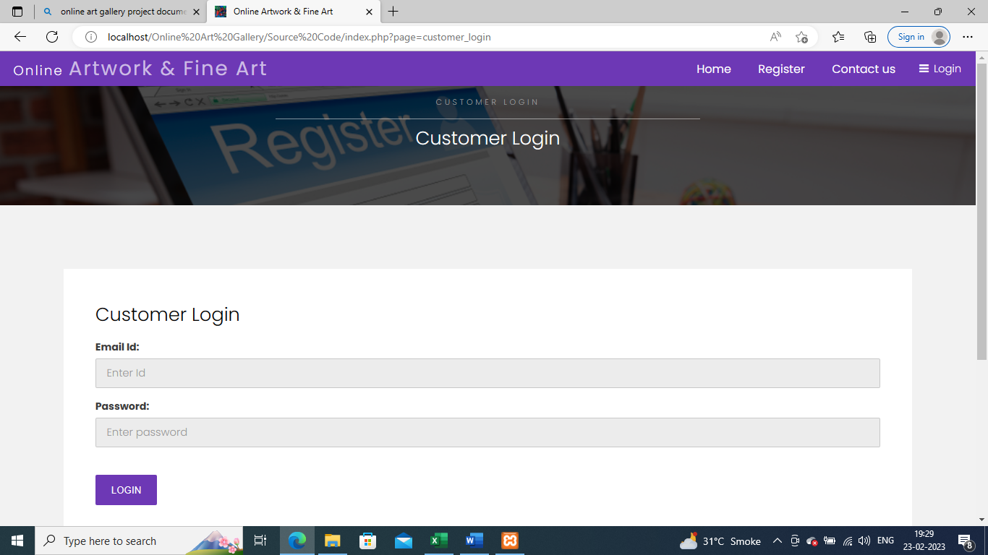

Figure 7.2 Login page

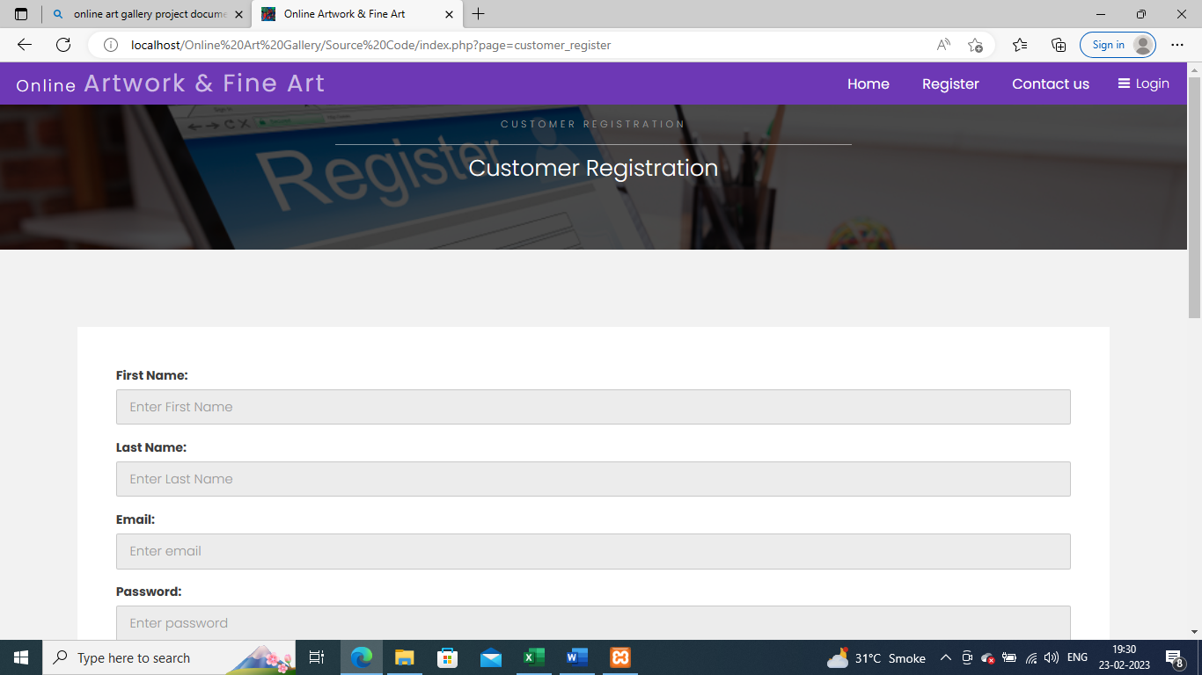

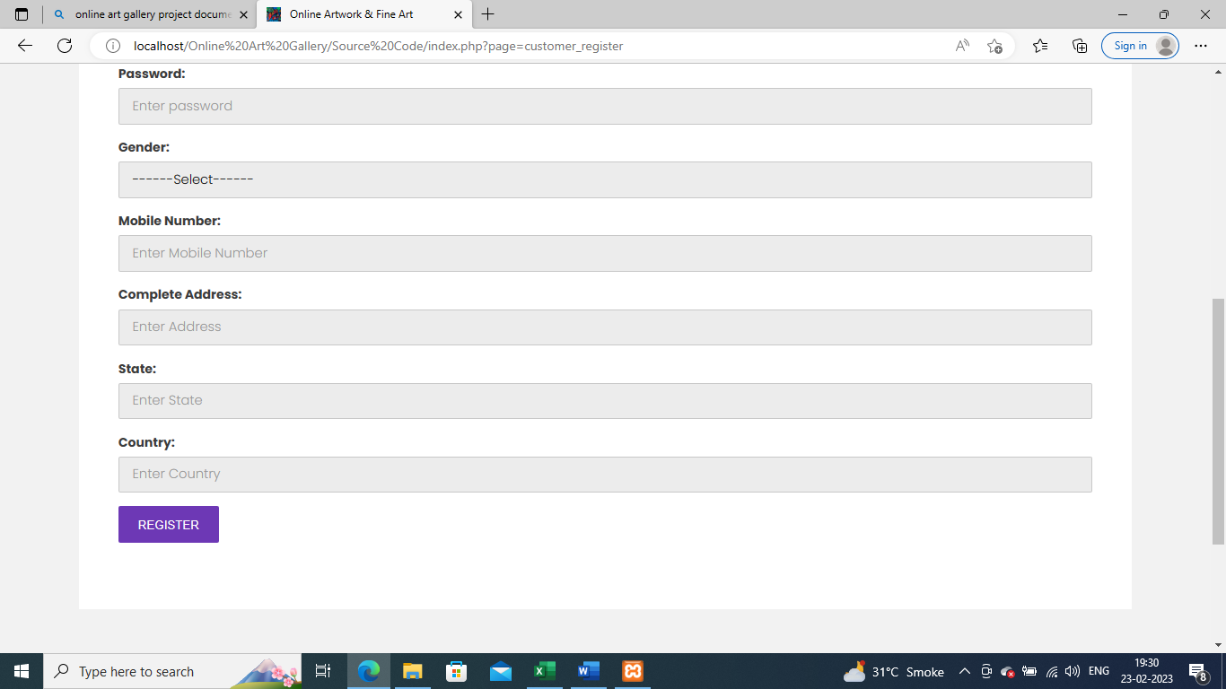

Figure 7.3 Registration page

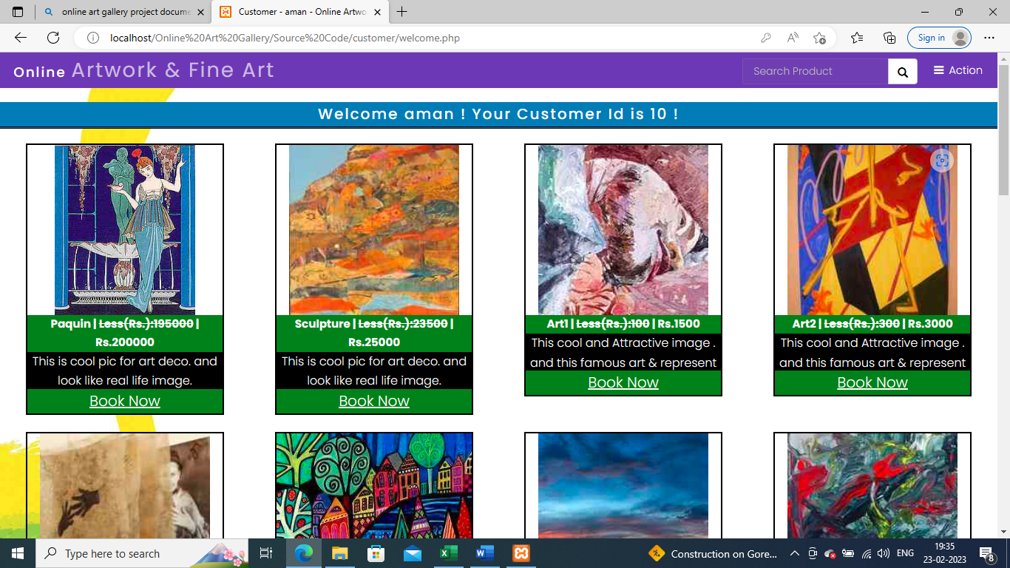

Figure 7.4 Welcome page

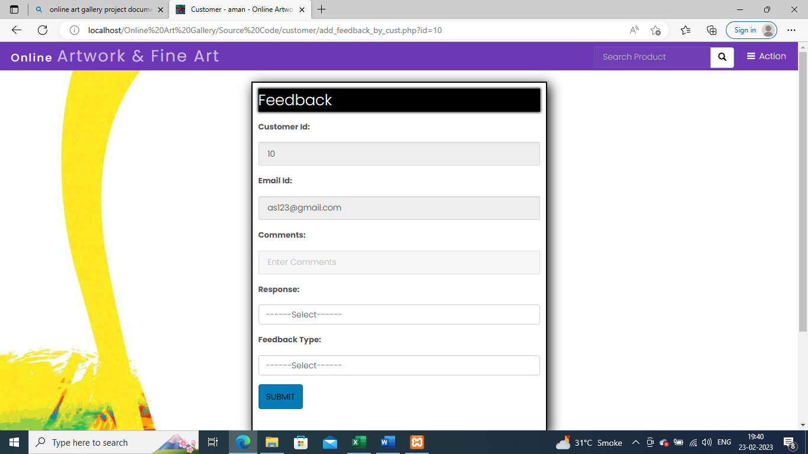

Figure 7.5 Feedback page

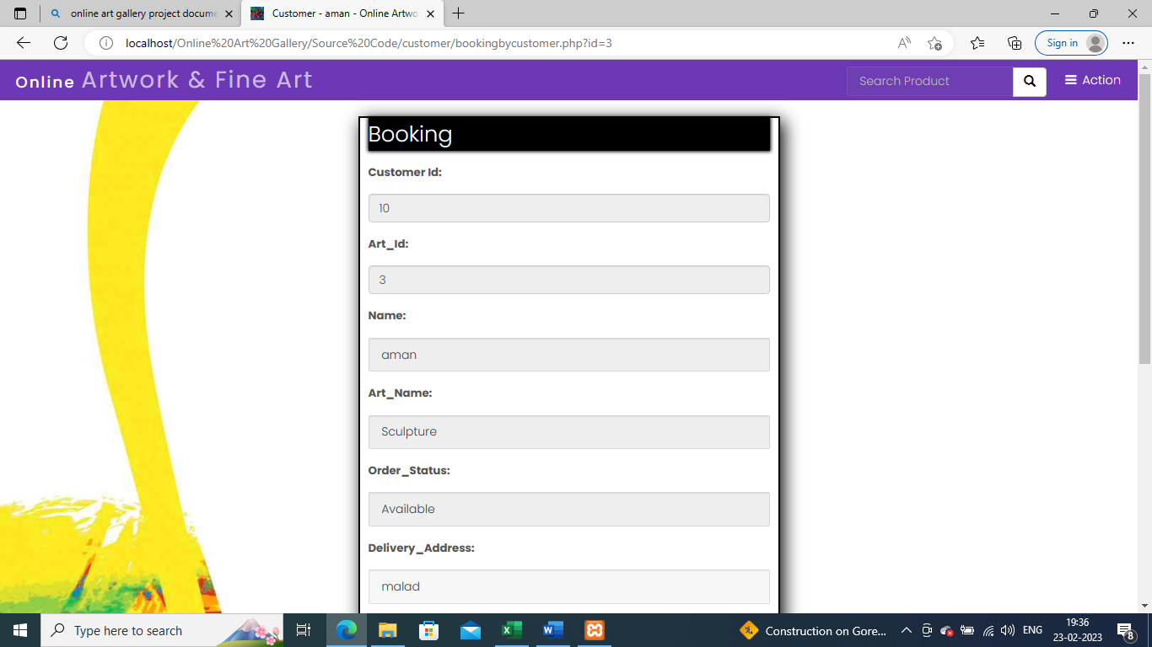

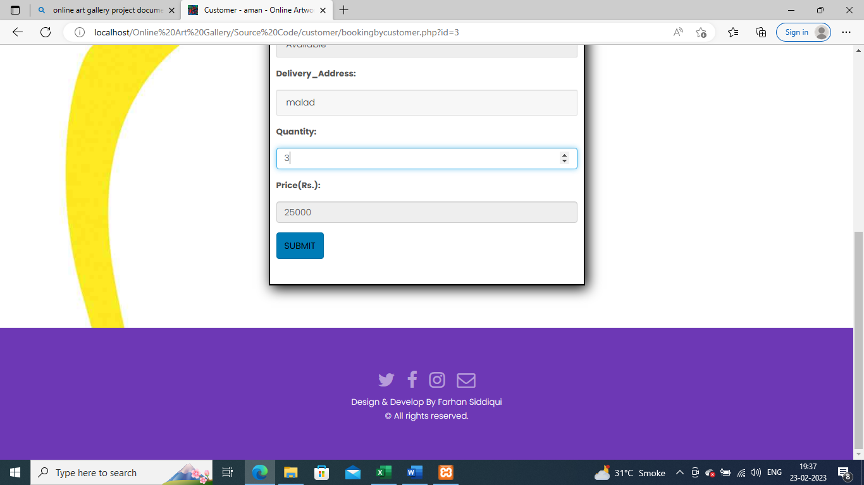

Figure 7.6 Booking page

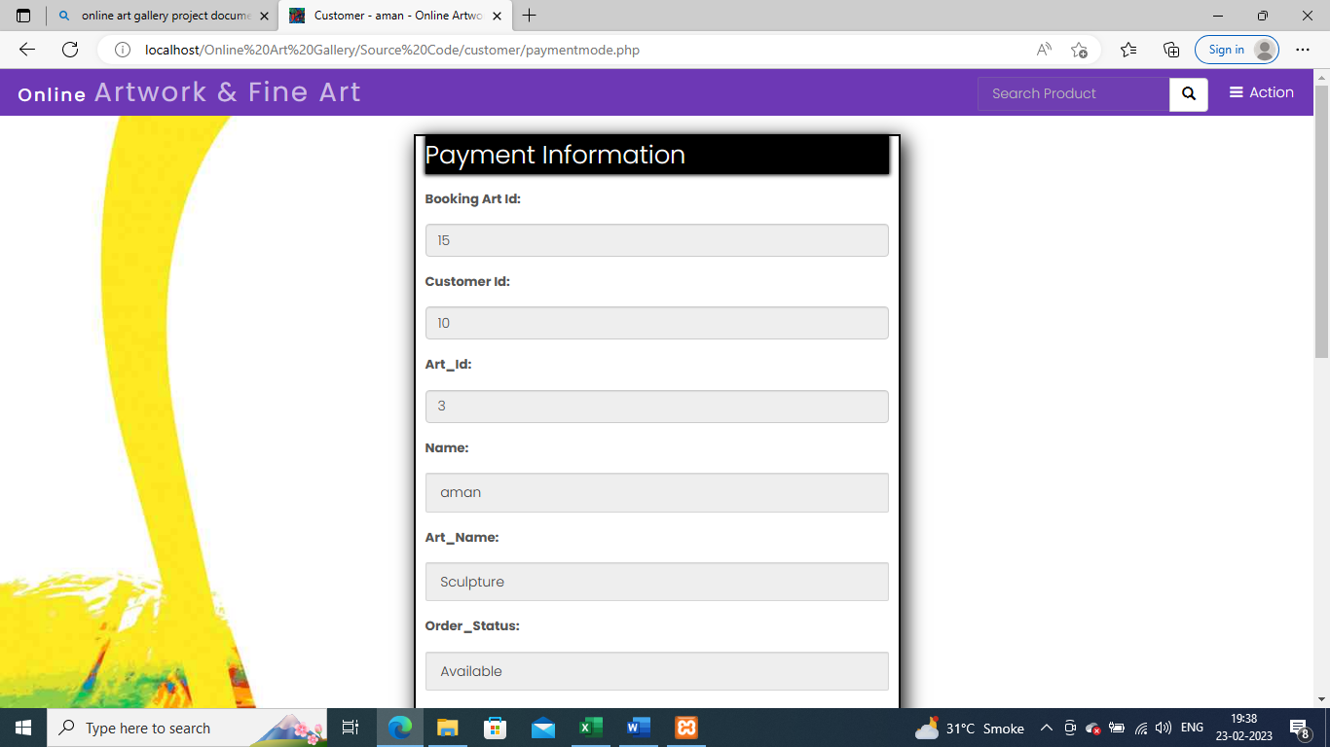

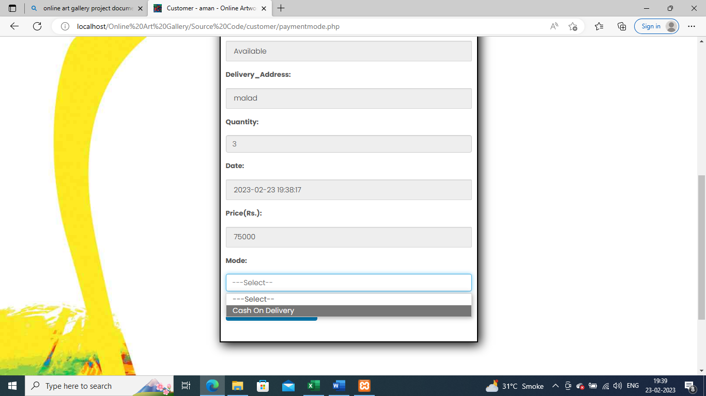

Figure 7.7 Payment page

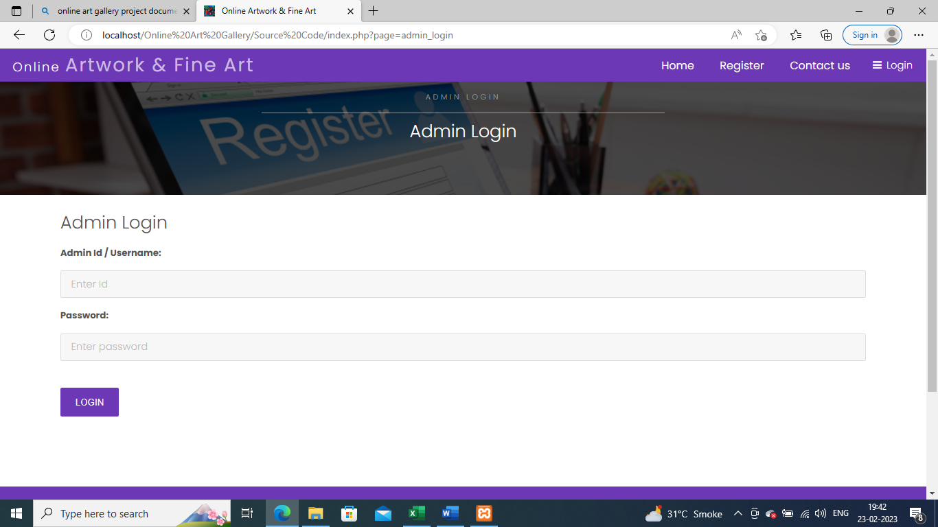

Figure 7.8 Admin login

## 5.2 Testing Approach and Test Cases

**Black Box**

|  |  |  |  |  |  |  |
| --- | --- | --- | --- | --- | --- | --- |
| **Test case no:** | **Components** | **Description** | **Input values** | **Expected Output** | **Actual Output** | **Remarks** |
| 1 | Username | All input | Null | Please enter  Valid username. | Please enter  Valid username. | Fail |
|  | Username | All input | [a-z,A-Z,0-9] | Accept | Accept | Pass |
| 2 | Password | All input | Null | Please enter Password | Please enter Password | Fail |
|  | Password | All input | Not null | Accept | Accept | Pass |
| 3 | Login Button | Perform event | Click while all or some field are null | Display proper message for all fields | Display proper message for all fields | Fail |
|  | Login Button | Perform event | Not null | Accept | Accept | Pass |

Table 2: Test Case: Login

**Registration**

|  |  |  |  |  |  |  |
| --- | --- | --- | --- | --- | --- | --- |
| **Test case no** | **Components** | **Description** | **Input values** | **Expected output** | **Actual output** | **Remarks** |
| 1 | Firstname | Enter Firstname | null | This field is required | This field is required | Fail |
|  | Firstname | Enter Firstname | [a-z, A-Z] | Accept | Accept | Pass |
| 2 | Lastname | Enter Lastname | null | This field is required | This field is required | Fail |
|  | Lastname | Enter Lastname | [a-z, A-Z] | Accept | Accept | Pass |
| 3 | Username | Enter Username | Null | This field is required | This field is required | Fail |
|  | Username | Enter Username | [a-z, A-Z,0-9, @, _, .] | This field is required | This field is required | Pass |
| 4 | Password | All input | Null | This field is required | This field is required | Fail |
|  | Password | All input | invalid | Invalid input | Invalid input | Fail |
|  | Password | All input | Not null | Accept | Accept | Pass |
| 5 | Confirm password | All input | Null | This field is required | This field is required | Fail |
|  | Confirm password | All input | Mismatch with password | Invalid input | Invalid input | Fail |
|  | Confirm password | All input | Not null | Accept | Accept | Pass |
| 6 | Email | Enter email | invalid | Invalid input | Invalid input | Fail |
|  | Email | Enter email | Email type | Accept | Accept | Pass |

Table 3: Test Case: Registration

# CHAPTER 6

# RESULTS AND DISCUSSION

## 6.1 Test Reports

Login



Table 4: Test Reports: Login

Registration



Table 5: Test Reports: Registration

## 6.2 User Documentation

* To login the Buyer should have a User id and Password.
* If the Buyer doesn’t have a User id and password, he can create a new account by clicking on sign up button.
* Buyer can buy any Product available in stock by just selecting the product, filling shipping form, and card details.
* The Product will be added to the buyer’s order report. Orders can only be placed when buyer is logged in with his credentials.
* Buyers order report page has Order ID, Date of order, Total amount of order, Status of the order, and action.
* Once Buyer clicks action, he can see all the Art he ordered in that order.

# CHAPTER 7

# CONCLUSIONS

## 7.1 Conclusions

online art galleries are the future scope of selling, exhibiting the art works market. Gradually it will be more and more improved and grow throughout the world. The “Online Art Gallery” has been developed by us through applying our knowledge referring to certain images, browsing some sites and through the help of external and internal faculties and using our own knowledge related to the subject itself. The system has been made so transparent for the users so that client can trust and have faith in reliability of information. Our system is users friendly and users will be satisfied with the system. At the last I should say that technology is the future of everything so as soon the artists adapt it will be beneficial for art world. The Information era also gives opportunity to virtual art gallery to flourish.

## 7.1.1 Significance of the System

* **Accessibility:** An online art gallery provides access to a vast collection of artworks from around the world to anyone with an internet connection. This accessibility allows art lovers to discover new artists and artworks they might not have had access to before.
* **Convenience:** An online art gallery allows buyers to purchase artworks from the comfort of their homes. This convenience saves time and effort that would have been spent visiting a physical art gallery.
* **Cost-Effective**: Setting up an online art gallery is often less expensive than opening a physical art gallery. It eliminates costs associated with renting or owning a physical space, utilities, and staffing.
* **Curation:** An online art gallery can curate artworks from different artists, making it easier for buyers to discover new artists and artworks.
* **Feedback:** An online art gallery allows buyers to provide feedback on artworks, which can help artists improve their craft.

## 7.2.1 Limitation of the System

* **Lack of physical interaction:** Online art galleries lack the physical interaction that buyers and collectors may have with the artworks. This can be a limitation for some buyers who prefer to see the artwork in person before making a purchase.
* **Limited information:** While online art galleries provide images and descriptions of artworks, they may not provide enough information on the artwork's materials, texture, and overall condition. This limitation can be a disadvantage for collectors who are looking for specific artworks.
* **Competition:** The online art gallery space is becoming increasingly competitive, with many galleries and artists vying for the attention of potential buyers. This can make it challenging for emerging artists to stand out and gain exposure.
* **Security:** Online art galleries may be vulnerable to security breaches, such as hacking or theft of personal information. This can be a disadvantage for buyers who are concerned about the security of their personal and financial information

## 7.3 Future Scope of the Project

* Artist Can Also upload their artwork at website.
* The potential plans include secure payment gates so that customers pay via websites of third parties using this system to maximize customer privacy.
* Certain changes include smart ratings, the introduction of customer loyalty software. The ability to allow a user to provide a rating to the Online Art Gallery website overall.
* Proposed art e-gallery will be globally available on Internet. Buyer’s approach to art and willingness to value a piece of art by paying the right price varies from country to country and culture to culture.
* Research needs to be sought on enhancing specific feature of the online galleries such as enhancing the uploaded image quality of the artwork on the website. Addition of a video clip where the artist himself/herself describes the artwork.

# REFERENCES

* <https://youtu.be/KZHF2FKJtK>
* <https://www.youtube.com/@CodeWithHarry>
* <https://www.youtube.com/@MrWebDesignerAnas>
* <https://stackoverflow.com/questions/css>
* [www.javatpoint.com/javascript](http://www.javatpoint.com/javascript)
* <https://www.javatpoint.com/form-validation-in-php>
* <https://bootsnipp.com/tags/registration>
* <https://www.tutorialspoint.com/internet_technologies/javascript.htm>
* <https://www.geeksforgeeks.org/form-validation-using-html-javascript>
* <https://projectworlds.in/free-projects/php-projects/>
* <https://www.campcodes.com/projects/php/>
* <https://phpgurukul.com/art-gallery->
* <https://www.sourcecodester.com/php>
* <https://github.com/Piyushhbhutoria/Art-Gallery>
* <https://itsourcecode.com/free-projects/python-proj>
* <https://www.slideshare.net/SayeedMahmud3/art-gallery>
* <https://codingsutra.in/online-art-gallery>
* [www.academia.edu/24386387/Online_Art_Gallery](http://www.academia.edu/24386387/Online_Art_Gallery)
* <https://www.scribd.com/doc/225596113/Online-Art-G…>
* <https://epdfx.com/download/online-art-gallery-documentation>
* <https://idoc.pub/documents/online-art-gallery-project-report>
* <https://www.lovelycoding.org/art-gallery->
* <https://freeprojectsforall.com/php-project>
* <https://www.researchgate.net/publication/345016518_ONLINE_ART_GALLERY>

# APENDIX

An online art gallery is a virtual platform that allows artists and art enthusiasts to display, browse, and purchase art. Online art galleries can showcase a variety of art forms, including paintings, sculptures, photography, digital art, and more.

Online art galleries offer many benefits over traditional brick-and-mortar galleries, including wider reach, accessibility, and convenience. They allow artists to reach a global audience, showcase their work to potential buyers, and make sales online without the need for physical presence.

Art enthusiasts can browse online art galleries from anywhere in the world, at any time, and easily discover new artists and art forms. They can also make purchases online, making the process of buying art more convenient and accessible.

Online art galleries typically have a range of features to help artists and buyers navigate the site, including search filters, sorting options, and user reviews. They may also offer additional services such as framing, shipping, and insurance.

Overall, online art galleries are an increasingly popular platform for artists and art enthusiasts to connect, buy, and sell art in a digital age.